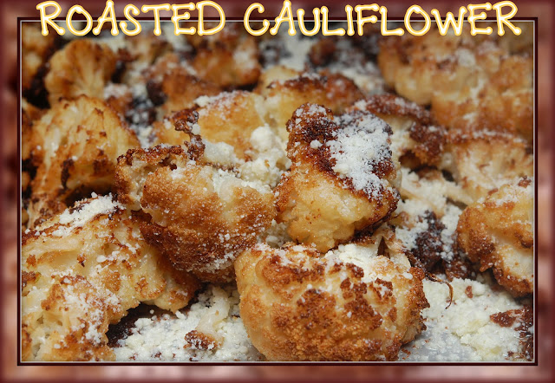

1 head cauliflower, cut into 1/2 -1 inch florets
1/2 cup fresh bread crumbs
1/4 cup freshly grated Parmesan
1/4 cup olive oil
Salt and pepper to taste
Preheat oven to 400º.
Toss florets with olive oil, bread crumbs and cheese. Spread in a single layer on jelly roll sheet lined with nonstick foil. Season with salt and pepper. Roast 30-40 minutes, until nicely browned.

